Normal Distribution

R has four in built functions to generate normal distribution. They are described below.

dnorm(x, mean, sd)

pnorm(x, mean, sd)

qnorm(p, mean, sd)

rnorm(n, mean, sd)

Following is the description of the parameters used in above functions −

* **x** is a vector of numbers.
* **p** is a vector of probabilities.
* **n** is number of observations(sample size).
* **mean** is the mean value of the sample data. It's default value is zero.
* **sd** is the standard deviation. It's default value is 1.

## dnorm()

This function gives height of the probability distribution at each point for a given mean and standard deviation.

# Create a sequence of numbers between -10 and 10 incrementing by 0.1.

x <- seq(-10, 10, by = .1)

# Choose the mean as 2.5 and standard deviation as 0.5.

y <- dnorm(x, mean = 2.5, sd = 0.5)

# Give the chart file a name.

png(file = "dnorm.png")

plot(x,y)

# Save the file.

dev.off()

When we execute the above code, it produces the following result −

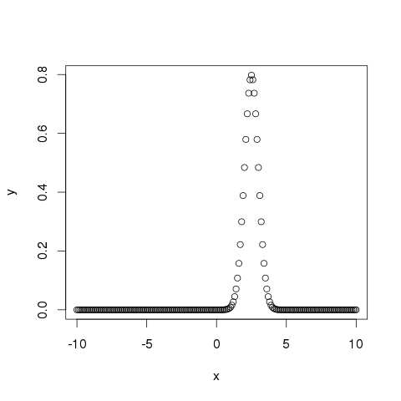

## pnorm()

This function gives the probability of a normally distributed random number to be less that the value of a given number. It is also called "Cumulative Distribution Function".

# Create a sequence of numbers between -10 and 10 incrementing by 0.2.

x <- seq(-10,10,by = .2)

# Choose the mean as 2.5 and standard deviation as 2.

y <- pnorm(x, mean = 2.5, sd = 2)

# Give the chart file a name.

png(file = "pnorm.png")

# Plot the graph.

plot(x,y)

# Save the file.

dev.off()

When we execute the above code, it produces the following result −

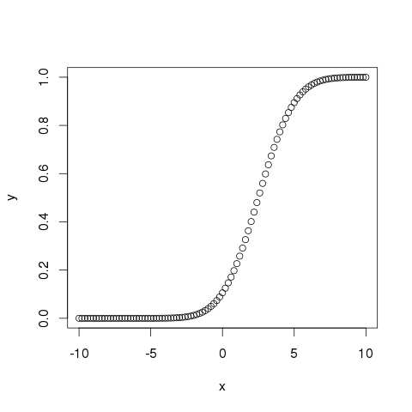

## qnorm()

This function takes the probability value and gives a number whose cumulative value matches the probability value.

# Create a sequence of probability values incrementing by 0.02.

x <- seq(0, 1, by = 0.02)

# Choose the mean as 2 and standard deviation as 3.

y <- qnorm(x, mean = 2, sd = 1)

# Give the chart file a name.

png(file = "qnorm.png")

# Plot the graph.

plot(x,y)

# Save the file.

dev.off()

When we execute the above code, it produces the following result −

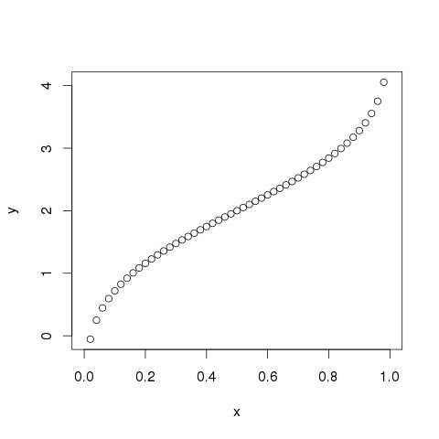

## rnorm()

This function is used to generate random numbers whose distribution is normal. It takes the sample size as input and generates that many random numbers. We draw a histogram to show the distribution of the generated numbers.

# Create a sample of 50 numbers which are normally distributed.

y <- rnorm(50)

# Give the chart file a name.

png(file = "rnorm.png")

# Plot the histogram for this sample.

hist(y, main = "Normal DIstribution")

# Save the file.

dev.off()

When we execute the above code, it produces the following result −

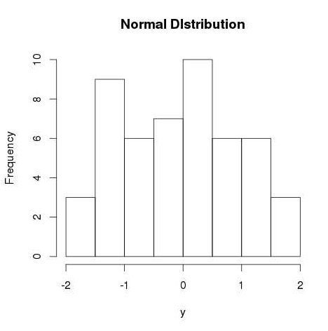

# Binomial Distribution

The binomial distribution model deals with finding the probability of success of an event which has only two possible outcomes in a series of experiments. For example, tossing of a coin always gives a head or a tail. The probability of finding exactly 3 heads in tossing a coin repeatedly for 10 times is estimated during the binomial distribution.

R has four in-built functions to generate binomial distribution. They are described below.

dbinom(x, size, prob)

pbinom(x, size, prob)

qbinom(p, size, prob)

rbinom(n, size, prob)

Following is the description of the parameters used −

* **x** is a vector of numbers.
* **p** is a vector of probabilities.
* **n** is number of observations.
* **size** is the number of trials.
* **prob** is the probability of success of each trial.

## dbinom()

This function gives the probability density distribution at each point.

# Create a sample of 50 numbers which are incremented by 1.

x <- seq(0,50,by = 1)

# Create the binomial distribution.

y <- dbinom(x,50,0.5)

# Give the chart file a name.

png(file = "dbinom.png")

# Plot the graph for this sample.

plot(x,y)

# Save the file.

dev.off()

When we execute the above code, it produces the following result −

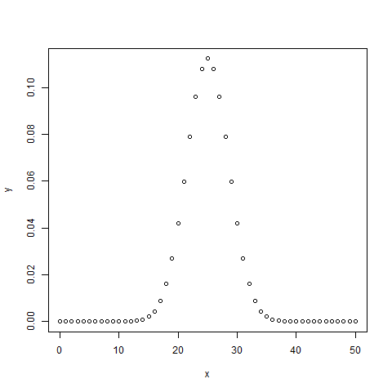

## pbinom()

This function gives the cumulative probability of an event. It is a single value representing the probability.

# Probability of getting 26 or less heads from a 51 tosses of a coin.

x <- pbinom(26,51,0.5)

print(x)

When we execute the above code, it produces the following result −

[1] 0.610116

## qbinom()

This function takes the probability value and gives a number whose cumulative value matches the probability value.

# How many heads will have a probability of 0.25 will come out when a coin is tossed 51 times.

x <- qbinom(0.25,51,1/2)

print(x)

When we execute the above code, it produces the following result −

[1] 23

## rbinom()

This function generates required number of random values of given probability from a given sample.

# Find 8 random values from a sample of 150 with probability of 0.4.

x <- rbinom(8,150,.4)

print(x)

When we execute the above code, it produces the following result −

[1] 58 61 59 66 55 60 61 67